
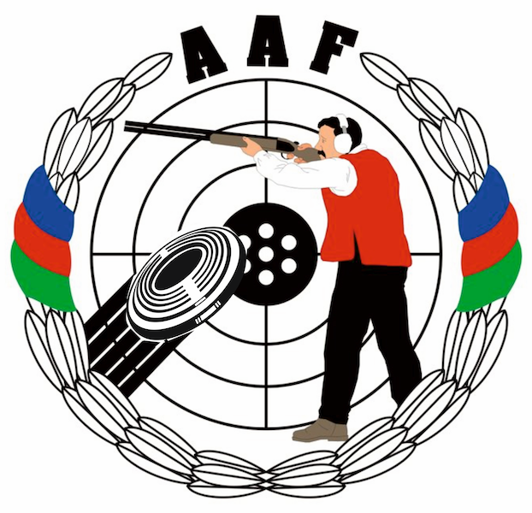
HEYDAR ALIYEV
INTERNATIONAL GRAND PRIX
Gabala, Azerbaijan
14 – 21 August 2014

Please email to Organizing Committee: info@gabala.eu

PRELIMINARY ENTRY FORM |  |  |  |  | Please return by |  |  | 15 APR 2014
name of federation |  |  |  |  | nation
contact person |  |  |  |  | phone number
e-mail address |  |  |  |  | fax number
ATHLETES
events men |  |  | number  of starts |  | events women |  |  |  | number  of starts
Trap Men |  |  |  |  | Skeet Men
Trap Women |  |  |  |  | Skeet Women
Trap Junior Men |  |  |  |  | Skeet Junior Men
OFFICIALS |  |  |  |  | number of officials
Team officials and media persons
Total number of athletes
Total number of officials

